Global Similarities and Persistent Differences: A Survey of Comparative Studies on Climate Change Communication

James Painter and Mike S. Schäfer

Abstract: A focus on international comparisons of media coverage of climate change is important because of its inherently transnational character and because of the role the media play in shaping the context within which different publics are made aware of climate change. However, there are significant gaps in our understanding of the differences between countries. The few studies that have been published show that, on the one hand, a number of important cross-national parallels exist in climate change coverage with regards to the amount of media coverage on climate change, the basic frame sets and the increasing focus on socio-political instead of scientific aspects of the issue. On the other hand, persistent differences prevail in the amount of space given to sceptical voices, the volume of coverage, and the dominant frames used to interpret climate change. Using these three (and other) metrics we would aim to draw out what we know about the main differences between Anglophone countries, continental European countries and countries in the ‘Global South’. In an increasingly fragmented media landscape in many countries, new digital-only players, such as Huffington Post, Vice and BuzzFeed, are making inroads into the dominance of legacy media with a strong emphasis on coverage of the environment and a growing presence in a variety of languages and countries.

1 Introduction: A Comparative Perspective on Climate Change Communication

Climate change is a phenomenon that transcends national boundaries and has been interpreted as a symbol of a “world risk society” (Beck, 2008, 81ff.). Climatic changes are observable on all continents (IPCC, 2014) and have social, economic and political impacts around the globe (e.g. Dryzek et al., 2011).

Climate change is also perceived, interpreted and contextualized differently in different countries; the global phenomenon is “domesticated” in different ways (Eide & Kunelius, 2010). The news media play an important role in this process. Due to climate change being a complex, large-scale, invisible process and, thus, an “unobtrusive” issue for many (Moser, 2010), news media are crucial sources for many peoples‘ information about climate change. Their coverage on climate change plays an important role in shaping the context within which different publics are made aware of climate change, and are prepared to take action to combat it (e.g. Carvalho, 2010, p. 172).

Due to the importance of news media and the global yet differentiated importance of climate change in different countries, international comparisons of media coverage of climate change are of considerable interest. Yet such studies are not that common. Even though research on climate change communication has expanded considerably in recent years (Moser, 2016; Schäfer & Schlichting, 2014), comparative analyses make up only a fifth of available studies, and their proportion has decreased over time (Schäfer & Schlichting, 2014: 152ff.).

In addition, there are significant gaps in our understanding of the similarities and differences between countries. Scholarship focuses on “Western”, mostly Anglophone countries, and has neglected African, Latin American and many Asian countries (Schäfer & Schlichting 2014; for some exceptions see Eide et al., 2010; Schmidt et al., 2013; Shanahan, 2009). Moreover, due to different analytical foci as well as varying data, analyzed periods of time and research methods, comparing results across studies is difficult as the “functional equivalence” (Esser, 2010) of measurements across contexts is often lacking.

The aim of this chapter, therefore, is to identify similarities and differences between countries and regions as well as research gaps, focusing on media representations.

2 Global Similarities in Climate Change Reporting

Cross-national, comparative research on climate change communication has focused on many facets (for an overview see Schäfer, 2015): the degree of attention media devote to the issue (e.g. Schmidt et al., 2013), the events triggering such coverage (Barkemeyer et al., 2017; Liu et al., 2011; Schäfer et al., 2014), the sources journalists quote (Eide et al., 2010; Painter et al., 2016), and the evaluation and framing of the issue including “sceptical” framing (O’Neill et al., 2015; Painter, 2011; Painter & Ashe, 2012). These studies have shown differences and similarities between the analyzed countries.

Firstly, and notwithstanding country differences (see section 3), scholarship has shown that climate change has received a significant amount of media coverage globally since the mid-2000s, particularly compared to other scientific or environmental issues. In most countries, the proportion of climate-related news articles has increased since 2000-2005, with peaks occurring between 2007 and 2009 (depending on the country), and around COP21 in 2015 (see Figure 1 and Gifford et al., 2017; Schmidt et al., 2013). Also, climate change has become a relevant topic in many countries compared to other issues. A 27-country analysis of media attention for climate change which used similar methodology on countries from all continents in order to ensure equivalent measurements established that climate change was mentioned in between 0.28 % (India) and 1.42% (Australia) of all published print media articles between 1997 and 2009 (Schmidt et al., 2013). These figures rose to between 0.54% (Russia) and 3.61% (again Australia) from 2006 to 2009. These percentages outnumber media coverage about other controversial scientific issues: Stem cell research, for instance, received 0.12% of media attention in Germany between 1997 and 2003, or the sequencing of the human genome received 0.06% in Germany (1993-2003), 0.08% in France (1999-2001) and 0.1% in the US (1999-2001, calculations based on Gerhards & Schäfer, 2006, 93ff.; Schäfer, 2007, p. 88, 2009).

Figure 1 Media Attention for Climate Change from 1996-2016 in Australia, Canada, Thailand, the UK, the US, India, New Zealand, and South Africa

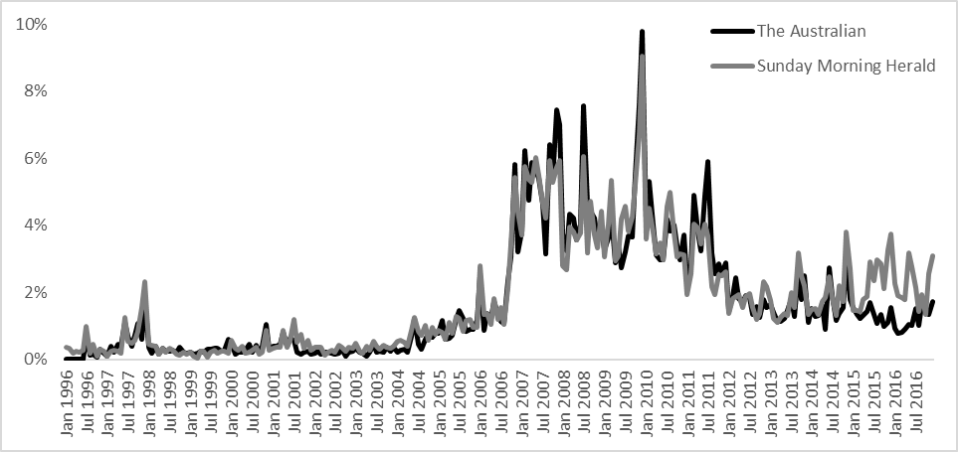
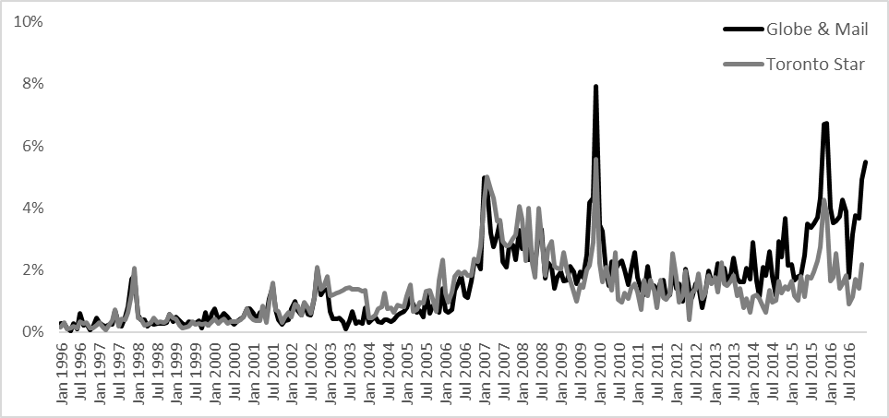
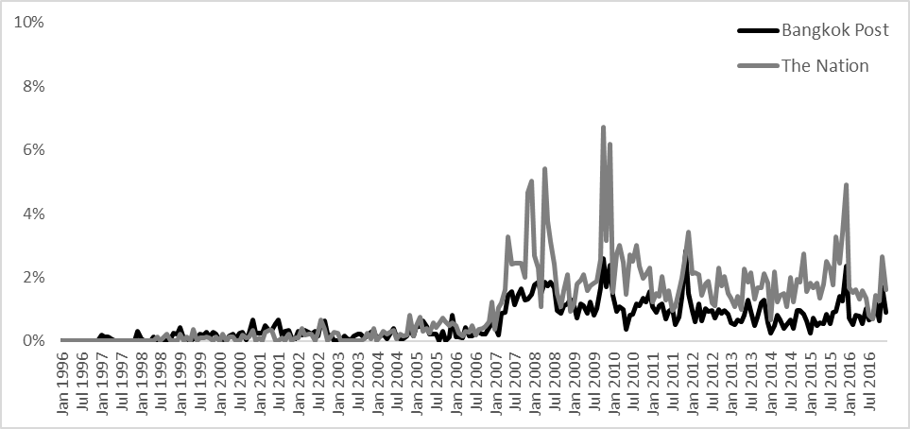
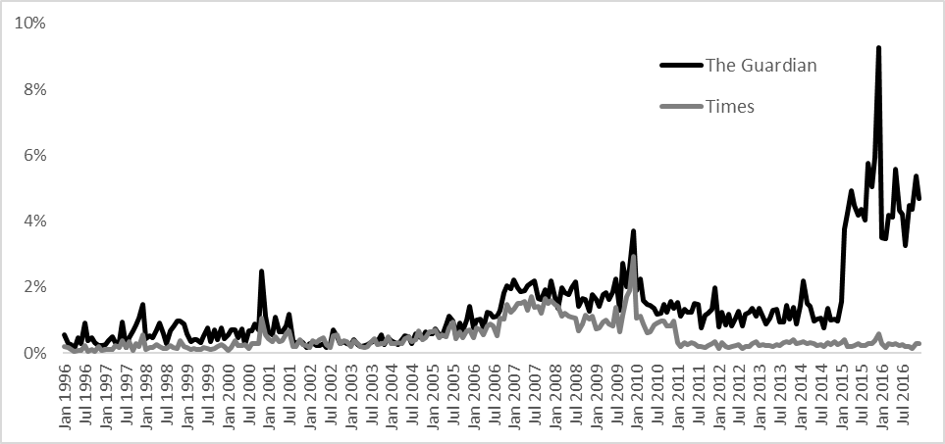
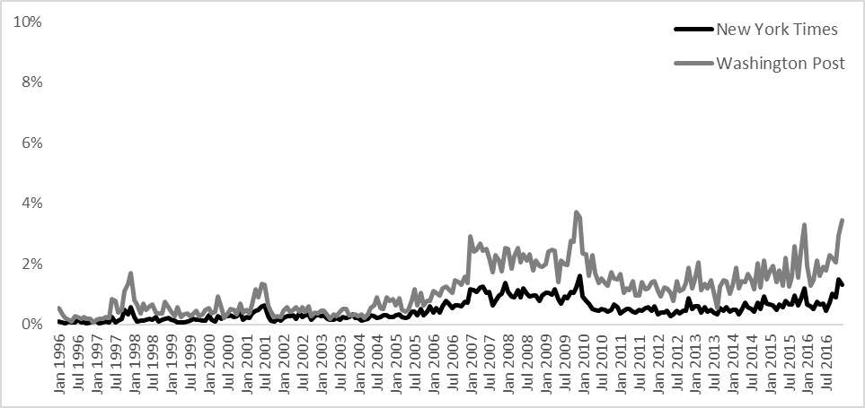
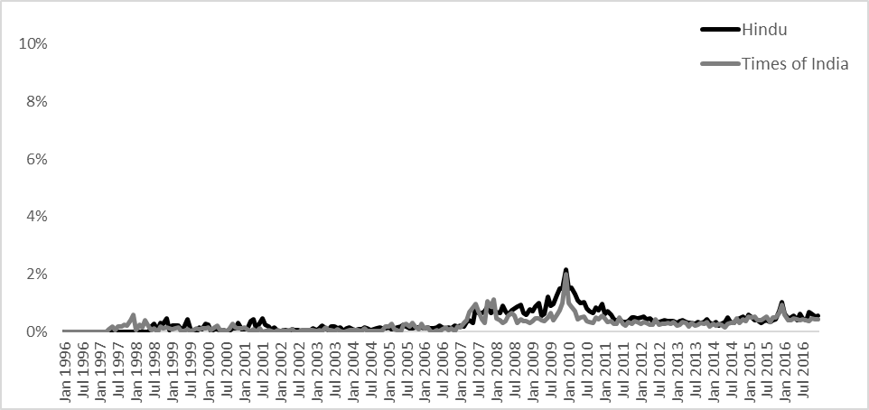
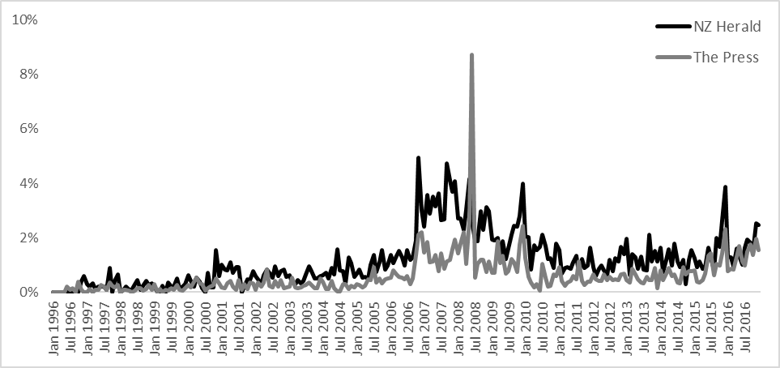
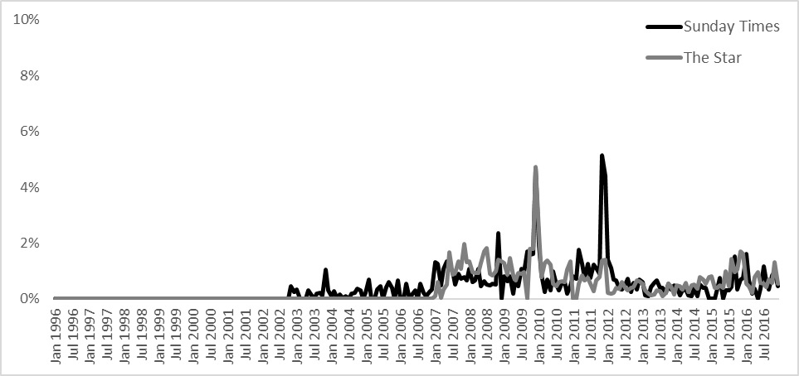
Note: Percentages indicate the amount of articles dealing with climate change (i.e. containing one of the keywords “climate change”, “global warming” or “greenhouse effect”, which are the most widely used keywords in studies on media attention (Schmidt et al., 2013), at least once) in relation to all articles published in the analyzed newspapers per month.

Secondly, studies have established that media coverage is strongly event-driven and episodic, and that it focuses on similar events across countries. Synchronized peaks in media coverage occur during selected Conferences of the Parties (COPs) to the United Nations Framework Convention on Climate Change (UNFCCC) and the publications of the Assessment Reports (ARs) of the IPCC, the Intergovernmental Panel on Climate Change (Eide et al., 2010; Gifford et al., 2017; Schmidt et al., 2013). Among the COPs, COP15 in Copenhagen in 2009, where the formulation of a successor agreement to the Kyoto Protocol was expected but ultimately fell short, figured prominently in media coverage, as did COP21 in Paris 2015 when an agreement was eventually reached (Painter et al., 2016). Climate-related media attention peaked around both events in practically all countries (see Figure 1), and time-series analysis also found COPs to be systematic triggers of media coverage on climate change in Australia, India and Germany (Schäfer et al., 2014).

Thirdly, many studies analyzing media coverage of climate change have focused on the “framing” of the issue. They have analyzed under which perspective the issue is presented in the media, which of its aspects are highlighted, as well as which claims, demands and responsibilities are deduced from it (for overviews see Nisbet, 2009; O’Neill et al., 2015). Comparative framing analyses have shown that the spectrum of frames prevalent in different countries displays many similarities. In their review of previous studies on framing climate change, O’Neill et al. (in the online appendix of O’Neill et al., 2015) show that the frames found in seven previous studies can be integrated into a generic set of ten climate change issue frames ranging from “settled science” and “uncertain science” frames over “disaster” and “opportunity” to “health” and “morality and ethics” frames (see also Painter et al., 2016).

In addition, empirical studies indicate that the relative prevalence of most frames in different Western countries is similar, particularly when coverage is driven by ‘events’ such as the publication of IPCC reports or COP meetings. For example, a six-country study analyzing newspaper coverage of the IPCC’s AR4 (4th Assessment Report), the 2012 IPCC report on extreme weather events, and Arctic sea ice melt in Australia, France, India, Norway, UK and the US showed that the distribution of frames was similar across countries, with the “disaster/implicit risk” and “uncertainty” frames clearly dominating (Painter, 2013).

Print media coverage of the IPCC’s 5th AR was also framed similarly in five developed (Canada, France, Japan, Norway and the UK) and five non-developed countries (Bangladesh, Brazil, Chile, Indonesia and South Africa) (Painter, 2017). Six of seven themes – disaster, uncertainty, skepticism, risk, opportunity of action and opportunity of inaction - occurred similarly often in these countries’ print media. The lack of cross-country differences was also found in television coverage of the IPCC’s AR5 (5th Assessment Report), where disaster and uncertainty were again much more prominent than risk and opportunity in Australia, Brazil, China, Germany, India and the UK (Painter, 2014). Visual framing in print coverage seems to be similar, as well, across the largest English- (O'Neill, 2013; O'Neill et al., 2013) and German-speaking countries (Metag et al., 2016, 199ff.), where climate change is visually presented using disaster framing and “talking heads”.

An analysis of print media content focusing on COPs 16 to 19 also concluded that the textual and visual framing of climate change and climate politics in Brazil, Germany, India, South Africa, and the United States is strongly convergent between the countries even though these frames are subsequently embedded into different national narratives (Lück, et al., 2016).

Fourthly, there seems to be a ‘societal turn’ in media coverage on climate change, i.e. a move away from debating the underlying science of climate change towards a debate of appropriate political measures and societal implications. Several indicators support this assumption, even though the evidence is more scarce here compared to the previous points. But content analyses analyzing media coverage over long time-spans in Germany have shown that climate change has moved from the science sections of the media, where it was mostly placed in the 1990s and early 2000s, into the politics, economy and even culture sections (Ivanova, 2012). (See Figure 2) Computer-assisted analyses of US media also provide evidence that words indicating scientific aspects of climate change have been used less often over time, whereas words indicating political or economic aspects have risen in importance (Kirilenko & Stepchenkova, 2012; Kirilenko et al., 2012). A shift away from scepticism about the science of climate change towards a scepticism surrounding the politics of climate change has been shown in the US as well (Schmid-Petri et al., 2015).

Figure 2. Editorial Placement of Articles about Climate Change in two leading German broadsheets, 1996-2010
Source: Ivanova, 2013

An analysis of print media coverage on climate change using corpus-linguistic methods for 11 countries including Australia, Canada, Germany, India, Namibia, New Zealand, Singapore, South Africa, Thailand, the UK and the US (Ivanova, 2017, 263ff.) reported similar results. It seems that while “the scientific basis of climate change is still being reported upon at times (and, especially in Anglo-Saxon countries, sometimes debated; Painter & Ashe, 2012), [a]spects like the political efforts towards a global treaty on emissions reductions, the costs of moving towards low carbon societies for national economies, or the humanitarian and security implications connected to potentially intensifying resource conflicts and climate-induced migration, are increasingly taking center stage” (Schäfer, 2015, 856ff.).

3 Persistent Country Differences

Despite these similarities in international media coverage, there are also persistent differences between countries in the volume of coverage, the amount of attention given to sceptics, the emphasis on different themes (away from set events or climate reports), and the degree of ‘domestication’. These differences often lie between ‘Anglosphere’ countries, continental European countries and countries in the ‘Global South’.

Country disparities in the volume of media coverage over time, which is often described as ‘issue attention’, have been monitored in different studies. A study of AR5 print coverage in 22 countries in 2013-14 showed differences between i) a group of industrialised, usually Anglosphere, countries (Australia, Canada, Finland, Japan, USA, and the UK, who published around 90 or more articles per news outlet), ii) a group of continental European countries (France, Germany, Norway, and Sweden who published 40 to 80 articles and iii) a group from the Global South (Bangladesh, Chile, China, Egypt, Ethiopia, Indonesia, South Africa and Uganda, who published between 5 and 40 articles). (Kunelius et al., 2017: 21)

Schmidt et al. (2013) have tried to ensure a greater ‘functional equivalence’ in measuring issue attention between countries. They used comparable data from 27 countries from 1996 to 2010, and found issue attention (measured by the mean percentages of the total articles in a newspaper dedicated to climate change) high in Australia, Canada, Indonesia and the UK, relatively high in France, Ireland, New Zealand and the USA, and relatively low or low in continental European countries (Germany, the Netherlands and Spain) and various countries in the Global South (including Brunei, India, and Mexico; see also Figure 1 for a continuation of similar data for eight countries).

Similar results emerged from another wide-ranging study, this time of 2.6 million articles in 32,000 newspaper issues across 113 newspapers published in 41 countries (Barkemeyer et al., 2017) in one year - 2008. Again, Australia, Canada and the UK had the highest volume of coverage at an average of more than two articles per newspaper issue. This was followed by a second group of countries at between one and two articles (China, Germany, India, Ireland, Mexico, and New Zealand). The USA was relatively high at 0.89 articles per issue. The lowest were Venezuela, Guatemala, Ecuador, Costa Rica and Russia at less than one article for every ten issues.

Less clear than these volume differences are their drivers - but also here, country differences are observable. Rooted in agenda-setting theory, multiple streams theory and punctuated equilibrium theory, Schäfer et al. (2014) showed that weather and climate characteristics are not very strong drivers of media coverage in Australia, Germany and India, and that international socio-political events like the COPs or domestic political debates and contestation trigger media coverage on climate change more strongly.

Generally, it seems clear that one of the main drivers of differences in issue attention is when aspects of climate change – the science explaining it, its impacts or the policy responses to it – are heavily contested in the political sphere. For example, in Australia, between June 2010 and September 2015, disputes over climate change policy played a significant causative role in the changing or removal of five prime ministers over this period (cf. Bacon & Nash, 2012). So high political contestation often translates into high media coverage of climate change, particularly as the media often take their cues from politicians (Brulle et al., 2012) and quote politicians as one of their main sources, even on the science (Painter, 2010). Indeed, Australia is one of a group of Anglosphere countries, along with Canada, the USA and the UK, where extensive media analysis has shown that various forms of scepticism, often held by right-wing politicians, is common, particularly in the opinion sections of the right-leaning legacy media (Painter and Gavin, 2016; Elsasser and Dunlap, 2013).

A third area of difference between countries can be found in the presence or absence of different themes or frames. As we have seen, the spectrum of themes is often similar across countries, but differences emerge from longitudinal studies focusing on the frequency of specific frames. We know that scepticism is more prominent in Anglosphere countries (Grundmann and Scott, 2014; Painter and Ashe, 2012; Painter 2011) and less prominent in continental Europe and developing countries like China and India (Dispensa and Brulle, 2003; Billett, 2010; Engels et al., 2013). Other studies have found, for example, that the presentation of climate change as a security issue differs markedly between Western countries, who strongly focus on national and energy security, and developing countries who place greater emphasis on food and water security (Schäfer et al., 2015). The Indian media exhibit some marked differences to those in developed countries. Billett (2010) showed from a study of the English language print media between 2002 and 2007 that the dominant frames were strongly shaped by a post-colonial and developmental approach rooted in India’s vulnerability to climate risks and a desire for a just distribution of responsibilities between developed and developing countries.

Finally, research has shown important differences in the degree of ‘domestication’ of climate change, i.e. in the degree to which the media in different countries “domesticate global climate politics by opening up national spaces of interpretation” (Kunelius and Yagodin, 2016: 84). These authors’ study of AR5 print media coverage in 22 countries showed a wide range of country differences, when it mapped how scientists, politicians, NGO representatives, businessmen and women and other sectors appeared as sources in the media. China, Finland, France, Germany, Japan, Poland, Russia, South Africa and Sweden were classified as exhibiting ‘high domestication’, Australia, Brazil, Canada, Norway, the UK and the USA ‘medium domestication’, and Bangladesh, Chile, Egypt, Ethiopia, Indonesia, Israel and Uganda as ‘low domestication’. Two studies focusing on the specific differences between the media in Germany and the USA have found that foreign voices are stronger in Germany, whereas domestic voices dominate in the US (Ivanova, 2017; Konieczny, 2013).

Country differences seem easier to map than to explain. No definitive study has come up with a robust, commonly-applicable framework for analyzing the main drivers of these differences. Researchers have chosen different variables, specific to the media and journalism in discrete countries, or wider societal factors, as the main explanatory forces behind the country differences. For example, Schmidt et al. (2013) chose two ‘societal’ variables to assess a correlation with media attention, namely a country’s vulnerability to climate risks and its carbon dependency. They found firstly, that anticipated climate risks did correlate with higher media attention in countries not bound by the Kyoto Protocol (i.e. non-Annex B), mostly found in the Global South; and secondly, that the extent of media attention in Annex B countries corresponded with the degree of carbon dependency. The paradigmatic case which supported the second hypothesis was Australia, which had high media attention and high carbon dependency. Most European countries in their study, by contrast, showed a lower carbon intensity of GDP and lower levels of media attention. However, there were some obvious, but significant, outliers. The UK is one of them, exhibiting high media attention but lower carbon dependency. Another was Russia, which had low media attention but a very carbon-reliant economy.

Barkemeyer et al. (2017) also select climate vulnerability as a country variable, but add a political dimension (the quality of a country’s regulatory regime), economic dimensions (level of economic development, carbon intensity, integration into the world economy), a labour dimension (unemployment levels), and a cultural dimension (distribution of religious denominations). They conclude that there is evidence for a correlation between levels of media coverage and a country’s direct exposure to climate change, and the measures taken to combat climate change. But crucially, they argue, a number of contextual factors play a major role, particularly regulatory quality (correlated with high media coverage) and unemployment levels (correlated with low media coverage as concern about high unemployment crowds out coverage of other issues).

These authors seem right to stress the societal context in which climate change reporting takes place. But such studies downplay the internal factors such as ‘first order’ or ‘second order’ journalistic norms like balance, dramatization or novelty (Boykoff and Boykoff, 2004, 2007; Boykoff 2007), editorial culture or norms (Nisbet et al., 2003), the influence of proprietors (McKnight, 2012), the role of a media organisation’s ideology (Carvalho and Burgess, 2005; Dirikx and Gelders, 2010; Painter and Gavin, 2016), and the resources available to journalists in different countries (Shanahan, 2009). They also leave out other contextual factors which may help to explain why climate change is subject to more political contestation in some countries compared to others (and often as a result, more coverage) such as the presence (or not) of organized scepticism through lobbying groups or think tanks (McCright & Dunlap, 2000; Oreskes & Conway, 2010; Painter, 2011), the influence of fossil fuel companies (Dispensa and Brulle, 2003), the presence of sceptical politicians, readers, or scientists (Painter, 2016), and country-specific cultural or political values (Kahan et al., 2011; Engels et al., 2013). In other words, higher levels of media coverage can be prompted by higher levels of political contestation, rather than by higher levels of government or popular concern.

4. The Role of New Online Players in Different Countries

In an increasingly fragmented media landscape in many countries, new ‘digital-born’ players, such as Huffington Post (HuffPo), Quartz, Vice, Vox, and BuzzFeed, form part of a new digital presence alongside blogs and microblogs, niche sites, social media platforms and legacy media sites making the transition from print versions to online or adding online presences to their existing platforms. Some of the digital-born players are making inroads into the dominance of legacy media, both for news in general and for news about the environment (Newman et al., 2016; Fletcher, 2016). Many of them place a strong emphasis on coverage of the environment, in part because they believe that this area is not covered well enough by legacy media, and is of particular interest to their younger target audience (Painter et al. 2016).
Mostly US-based, some of them are now investing heavily in various languages and discrete versions aimed at consumers in specific countries or regions. They vary greatly in terms of their business models, distribution strategies, and editorial priorities (Nicholls et al, 2016). Even though both Huffington Post and BuzzFeed rely on complicated algorithms to push out their content on a variety of social media, HuffPo was founded as a left-leaning news outlet, whereas BuzzFeed is essentially a tech company with a media layer on top (Painter et al., 2016: 13). Country differences in content produced by these new players are driven both by these variations and by a diversity of local factors such as the strength of existing legacy media, the relationship between parent company and local partner, the available resources, and the capacity for original journalism.
Some indication of the way digital-born players are different both to legacy players and to each other can be found in a detailed study of the media coverage of the Paris COP summit at the end of 2015 (Painter et al., 2016). For example, sharp differences emerged between legacy and digital-born players in the volume of coverage. The application of the same methodology to select articles from two legacy and three digital-born players in six countries gave a sample size of nearly 2,000 articles across 22 days of analysis. Of these over two-thirds appeared in legacy media, mostly in the left-leaning media. However, there were also sharp differences in the amount of coverage by the new players, and between countries (see Figure 3). Huffington Post in English and French stood out for the large number of articles. Indeed, in the UK, USA and France, Huffington Post’s coverage was larger than that of the right-leaning media organisation selected. In the case of the USA, it had the most volume of any outlet - more than double that of the New York Times. By contrast, in Spanish and German the volume was significantly less than legacy media.

Figure 3. Volume of coverage of COP21, by country and media type/organisation, 25/11/2016 to 16/12/2016

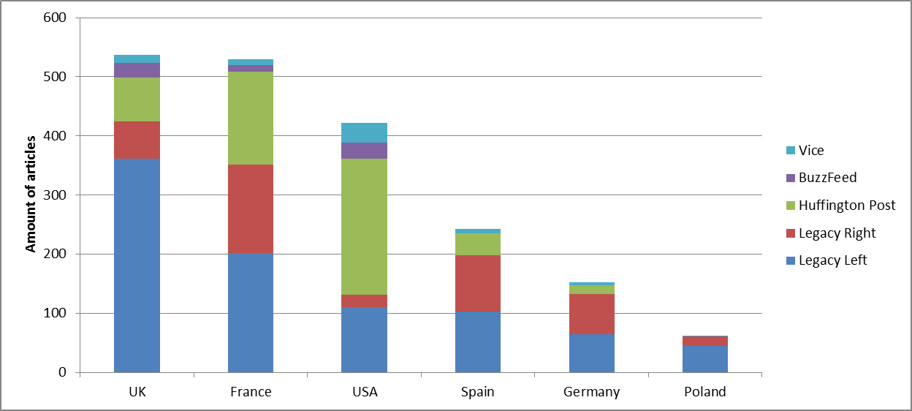
Source: Adapted from Painter et al., 2016.
Various explanatory factors come into play. In the USA, Huffington Post has identified a gap in environmental coverage, particularly for its target audience, in part caused by the crisis affecting the business models of legacy media there (Benson, 2016). However, the high volume is also a product of its business model which is driven by the imperative of publishing ‘volume’ so as to maximise the various types of advertising possibilities (native, display, video, programmatic) around the content. In France, another factor is that media in countries hosting COPs traditionally publish more than other countries due to the easier deployment of resources, the expectation of its audiences, and the ready availability of national politicians and other sources.
BuzzFeed and Vice publish much less content, in part because they specifically aim to be different from legacy media by selecting material or formats which makes them stand out and/or is shareable on social media. There are important country differences too: in Poland, Spain, and Germany, there was very little coverage of the summit, even though there are versions in those languages.
Probably the most important explanatory factor here are resources, as these countries have significantly fewer journalists working for these new sites compared to their parent sites in English (Painter et al., 2016). This may change if the new players achieve greater consolidation in different countries.
Huffington Post again is a different case, as they have reasonably sized newsrooms in France (around 30 full-time staffers in 2016), Germany (21) and Spain (15) – but significantly less than the USA (260) and the UK (40). In the first three countries, one of the many drivers of editorial output is Huffington Post’s relationships with its partner organisations, including the degree of collaboration or the desire for a distinct identity, and how much material is simply translated from the versions in English.
All three of them in most countries tended to cover the climate negotiations significantly less than the legacy media. (See Figure 4) Another difference is that all of them virtually ignored scepticism except to make fun of it. This contrasted with the scepticism found in the right-leaning legacy media in the Telegraph in the UK, USA Today, and Le Figaro in France. In the USA, UK and Germany, the Huffington Post placed considerable emphasis on reporting the opportunities opened up by climate change (such as green jobs in renewable energy), which is very much in line with the ‘solutions’ journalism promoted by its former owner, Arianna Huffington, and the approach offered by its editors who say they are ‘passionate about content which advertisers find attractive, including solution-based reporting and issues such as parenting or sustainability’ (Nicholls et al., 2016: 17).

Figure 4 Percentage of articles by media type/organisation covering the negotiations, as major and minor topic
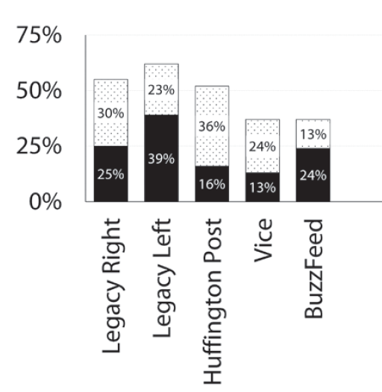

Source: Painter et al., 2016.

5 Conclusions

Climate change is global in character and in its impacts, and the attempts to alleviate the negative effects of climate change have often been located at an international or global level – epitomized by the annual climate change summits. We have summarized the main findings of comparative studies of climate change communication here, exemplifying them with our own research.
We were able to show that, on the one hand, a number of important cross-national parallels exist in climate change coverage: climate change has become a global media issue, where coverage is often event-driven and focuses particularly on global socio-political events like the COPs. The spectrum of interpretative frames present in different nations is relatively similar. And in many countries, a ‘societal turn’ seems to have occurred in which coverage turned away from the scientific aspects of climate change towards the political and social ones.

On the other hand, scholarship also points out persistent differences between countries. These regard the amount of space given to sceptical voices, the overall volume of climate change coverage in different countries, and the relative frequency of dominant frames used to interpret the topic other than in the coverage of set events or reports.

In addition, new digital-only players, such as Huffington Post, Vice and BuzzFeed, are making inroads into the dominance of legacy media with a strong emphasis on coverage of the environment and a growing presence in a variety of languages and countries. But their relative strength and importance also varies between countries quite significantly. Overall, our synopsis demonstrates the fruitfulness of a cross-nationally comparative perspective as well as the many limitations and gaps in current scholarship.

More comparative studies are needed, particularly ones comparing climate change coverage with (or between) countries in the Global South, with emerging economies such as China, India or Brazil (Lück et al., 2016; Painter, 2011), or focusing on the most vulnerable countries to climate change which are exclusively situated in the global south (Schäfer & Schlichting, 2014). For example, given the growing attention drawn to health risks associated with a changing climate such as a possible rise in human infectious diseases (Wu et al., 2016), changing consumption patterns of fruit and vegetables (Springman et al., 2016) or greater levels of air pollution (Hassan et al., 2016), we do not know if such risks are given more prominence in the media in developing countries where the impacts are more likely to be felt. One study of the US media showed that the number of print articles about public health risks rose markedly between 2011-12 compared to 2007-8 (Weathers and Kendell, 2016), but scholarship is lacking about the prominence of this theme in other countries. A similar point could be made about other aspects of the climate change ‘story’ such as extreme weather events, migration and displacement, or the causes of international disputes, and their possible links to climate change.

Furthermore, as print newspapers are in crisis in many countries, we need more analyses of TV – which is the main source of climate change-related information for many – and on online and social media, which are rising in importance. Such a shift would have to be accompanied by a focus on different modalities of climate change coverage, e.g. a focus on visuals and videos which are found in abundance in digital players like Vox and Quartz (Painter et al., 2016), and also on alt-right sites like Breitbart.

(Re)Assessing temporal trends that have been described in recent years between countries would also be worthwhile, especially in light of the rise of nationalist and/or populist movements in many countries which often advance scepticism towards climate change or display hostility towards institutionalized science or scientific ‘experts’.

Finally, as we have seen above, the relative weighting of factors internal to journalism and of contextual societal factors influencing media debates on climate change is difficult to pin down to explain country differences or similarities. This is due to the enormous variety of factors influencing journalists’ work in different countries, and the huge range of contextual factors evidenced by national economic, social and cultural indicators (Kunelius et al., 2017: 85-88). A good starting point for identifying the influences on the journalistic process can still be found in the work by Shoemaker and Reese (1996), which describes concentric circles ranging from ‘the micro-scale of individual attributes, to meso-influences of professional norms, work routines, and organizational cultures, to the macro-influences of economic imperatives, ownership structures, and cultural/ideological values’ (Gibson, 2017). So for example, in our understanding of why climate scepticism in common in the media of Anglosphere countries but not of others, such an approach could, as a replicable methodology, give insights into the relative strength of the roles played by editors, media owners, and individual journalistic values on the one hand, and the role of lobby groups, fossil fuel companies, skeptical politicians, and readers’ values on the other.

References

Bacon, W., & Nash, C. (2012). Playing the Media Game: The relative (in)visibility of coal industry interests in media reporting of coal as a climate change issue in Australia. Journalism Studies, 13(2), 243–258. doi:10.1080/1461670x.2011.646401
Barkemeyer, R., Figge, F., Hoepner, A., Holt, D., Kraak, J. M., & Yu, P.-S. (2017). Media coverage of climate change: An international comparison. Environment and Planning C: Politics and Space, 0263774X16680818. doi:10.1177/0263774X16680818.
Beck, U. (2008). World at Risk. Cambridge: Polity.

Billett, S. (2010). Dividing climate change: Global warming in the Indian mass media. Climatic Change, 99(1–2), 1–16.

Boykoff, M. T., & Boykoff, J. M. (2004). Balance as bias: Global warming and the US prestige press. Global Environmental Change, 14(4), 125–136.
Boykoff M. & Boykoff, J. 2007. Climate Change and Journalistic Norms: A Case-study of U.S. Mass-media Coverage. Geoforum, 38 (6), 1190-1204.
Boykoff, M. T. (2007). Flogging a dead norm? Newspaper coverage of anthropogenic climate change in the United States and United Kingdom from 2003 to 2006. Area, 39(2), 470–481.
Brulle, R., Carmichael J. & Jenkins C. (2012). Shifting public opinion on climate change: an empirical assessment of factors influencing concern over climate change in the U.S., 2002–2010. Climatic Change. 114 (2), 169-188.

Carvalho, A., & Burgess, J. (2005). Cultural circuits of climate change in U.K. broadsheet newspapers, 1985–2003. Risk Analysis, 25(6), 1457–1469.
Carvalho, A. (2010). Media(ted) discourses and climate change: a focus on political subjectivity and (dis)engagement. WIREs Climate Change, 1(2), 172–179. doi:10.1002/wcc.13
Dirikx, A., & Gelders, D. (2010). Ideologies overruled? An explorative study of the link between ideology and climate change reporting in Dutch and French newspapers. Environmental Communication, 4(2), 190–205.
Dispensa, J., & Brulle, R. (2003). Media’s social construction of environmental issues: Focus on global warming—a comparative study. The International Journal of Sociology and Social Policy, 23(10), 74–105.
Dryzek, J. S., Richard B. Norgaard, & David Schlossberg (Eds.). (2011). The Oxford Handbook of Climate Change and Society. Oxford: Oxford University Press.

Eide, E., & Kunelius, R. (2010). Domesticating Global Moments.A transnational study on the coverage of the Bali and Copenhagen Climate Summits. In E. Eide, R. Kunelius, & V. Kumpu (Eds.), Global Climate - local journalisms (pp. 11–50). Bochum: projektverlag.
Eide, E., Kunelius, R., & Kumpu, V. (Eds.). (2010). Global Climate - local journalisms. Bochum: projektverlag.
Elsasser, S. W., & Dunlap, R. E. (2013). Leading voices in the Denier choir: Conservative columnists’ dismissal of global warming and denigration of climate science. American Behavioral Scientist, 57(6), 754–776.
Engels, A., Hüther, O., Schäfer, M., & Held, H. (2013). Public climate-change scepticism, energy preferences and political participation. Global Environmental Change, 23(5), 1018–1027
Esser, F. (2010). Komparative Kommunikationswissenschaft. Working Paper No. 41. Zürich: National Centre of Competence in Research (NCCR).
Fletcher, R. (2016). The public and news about the environment. In: Painter et al. (eds.) Something old, something new: digital media and the coverage of climate change. Oxford, Reuters Institute for the Study of Journalism: 24-36.
Gerhards, J., & Schäfer, M. S. (2006). Die Herstellung einer öffentlichen Hegemonie. Humangenomforschung in der deutschen und der US-amerikanischen Presse. Wiesbaden: Verlag für Sozialwissenschaften.
Gibson T.A., (2017). Economic, Technological, and Organizational Factors Influencing News Coverage of Climate Change’ in the Oxford Research Encyclopedias: DOI:
10.1093/acrefore/9780190228620.013.355.
Gifford, L., Luedecke, G., McAllister, L., Nacu-Schmidt, A., Andrews, K., Boykoff, M., & Daly, M. (2017). World Newspaper Coverage of Climate Change or Global Warming, 2004-2017. Retrieved from http://sciencepolicy.colorado.edu/icecaps/research/media_coverage/world/index.html
Grundmann, R., & Scott, M. (2014). Disputed climate science in the media: Do countries matter? Public Understanding of Science, 23(2), 220–235.
Hassan N.A., Hashim Z., & Hashim J.H. (2016). Impact of Climate Change on Air Quality and Public Health in Urban Areas. Asia Pacific Journal of Public Health, 28(2S), 38S–
48S.
IPCC, (2014). Climate Change 2014. Synthesis Report. Geneva: Intergovernmental Panel on Climate Change.
Ivanova, A. (2012, May). Globale Medienereignisse in der "globalen MediaPolis"? Struktur und Bestimmungsfaktoren der Ähnlichkeit transnationaler Themenaufmerksamkeit. German Communication Association. 57. Jahrestagung der DGPuK, Berlin.
Ivanova, A. (2017). Transnationalisierung von Öffentlichkeiten. Eine länderübergreifende Längsschnittanalyse der Berichterstattung zum Klimawandel in führenden Tageszeitungen. Wiesbaden: Verlag für Sozialwissenschaften.

Kahan, D. M., Jenkins-Smith, H., & Braman, D. (2011). Cultural cognition of scientific consensus. Journal of Risk Research, 14(2), 147–174.
Kirilenko, A., Stepchenkova, S., Romsdahl, R., & Mattis, K. (2012). Computer-assisted analysis of public discourse: a case study of the precautionary principle in the US and UK press. Quality & Quantity, 46, 501–522.
Kirilenko, A., & Stepchenkova, S. (2012). Climate change discourse in mass media: application of computer-assisted content analysis. Journal of Environmental Studies and Sciences, 2(2), 178–191.
Konieczny, E. (2013). Gipfel, Krisen, Konferenzen: Die Entstehung Diskursiver Macht in transnationalen Kommunikationsereignissen: Springer-Verlag.
Kunelius R., E. Eide, M. Tegelberg, & D. Yagodin (Eds.), (2017). Media and Global Climate Knowledge: Journalism and the IPCC. New York: Palgrave MacMillan.
Liu, X., Lindquist, E., & Vedlitz, A. (2011). Explaining Media and Congressional Attention to Global Climate Change, 1969-2005: An Empirical Test of Agenda-Setting Theory. Political Research Quarterly, 64(2), 405–419. doi:10.1177/1065912909346744
Lück, J., Wessler, H., Wozniak, A., & Lycarião, D. (2016). Counterbalancing global media frames with nationally colored narratives: A comparative study of news narratives and news framing in the climate change coverage of five countries. Journalism, doi: 10.1177/1464884916680372
McCright, A. M., & Dunlap, R. E. (2000). Challenging global warming as a social problem: An analysis of the conservative movement’s counter-claims. Social Problems, 47(4), 499–522.
McKnight, D. (2012). Rupert Murdoch: An investigation of political power. Sydney, Australia: Allen & Unwin.
Metag, J., Schäfer, M. S., Füchslin, T., Barsuhn, T., & Kleinen-von Königslöw, K. (2016). Perceptions of Climate Change Imagery Evoked Salience and Self-Efficacy in Germany, Switzerland, and Austria. Science Communication, 38(2), 197–227.
Moser, S. C. (2010). Communicating climate change: history, challenges, process and future directions. WIREs Climate Change, 1, 31–53.
Moser, S. C. (2016). Reflections on climate change communication research and practice in the second decade of the 21st century: what more is there to say? Wiley Interdisciplinary Reviews: Climate Change, 7(3), 345–369. doi:10.1002/wcc.403
Newman, N., Fletcher R., Levy D. & Nielsen, R.K. (2016) Digital News Report. Oxford, Reuters Institute for the Study of Journalism.
Nicholls, T., Shabbir N., & Nielsen R.K. (2016) Digital-born News Media in Europe. Oxford, Reuters Institute for the Study of Journalism.
Nisbet, M. C., Brossard, D., & Kroepsch, A. (2003). Framing science the stem cell controversy in an age of press/politics. The International Journal of Press/Politics, 8(2), 36–70.
Nisbet, M. C. (2009). Communicating Climate Change: Why Frames Matter for Public Engagement. Environment, 51(2), 514–518.
Oreskes, N., & Conway, E. (2010). Merchants of doubt: How a handful of scientists obscured the truth on issues from tobacco smoke to global warming. New York: Bloomsbury Press.
O’Neill, S., Williams, H. T. P., Kurz, T., Wiersma, B., & Boykoff, M. (2015). Dominant frames in legacy and social media coverage of the IPCC Fifth Assessment Report. Nature Climate Change, 5(4), 380–385.
O'Neill, S. J., Boykoff, M. T., Niemeyer, S., & Day, S. (2013). On the use of imagery for climate change engagement. Global Environmental Change, 23(2), 413–421. doi:10.1016/j.gloenvcha.2012.11.006
O'Neill, S. J. (2013). Image matters: Climate change imagery in US, UK and Australian newspapers. Geoforum, 49, 10–19.
Painter, J., & Ashe, T. (2012). Cross-national comparison of the presence of climate skepticism in the print media in six countries, 2007–10. Environmental Research Letters, 7(4), 1–8.
Painter J., & Gavin, N. (2016). Climate skepticism in British newspapers, 2007–2011. Environmental Communication, 10(4), 432–452.
Painter, J., et al. (2016). Something old, something new. Digital media and the coverage of climate change. Oxford: Reuters Institute for the Study of Journalism.
Painter, J. (2010). Summoned by science: Reporting climate change at Copenhagen and beyond. Oxford: Reuters Institute for the Study of Journalism.
Painter, J. (2011). Poles Apart: The International Reporting on Climate Skepticism. Oxford: Reuters Institute for the Study of Journalism.
Painter, J. (2013). Climate Change in the Media: Reporting Risk and Uncertainty. Oxford: IB Tauris.
Painter, J. (2014). Disaster averted? Television coverage of the 2013/14 IPCC’s climate change reports. Oxford: Reuters Institute for the Study of Journalism.
Painter, J. (2016) ‘Journalistic Depictions of Uncertainty about Climate Change Across Countries’ in the Oxford Research Encyclopedias: DOI: 10.1093/acrefore/9780190228620.013.346
Painter, J. (2017). Disaster, Risk or Opportunity? A Ten-Country Comparison of Themes in Coverage of the IPCC AR5. In R. Kunelius, E. Eide, M. Tegelberg, & D. Yagodin (Eds.), Media and Global Climate Knowledge: 109–128. New York: Palgrave MacMillan.
Schäfer, M. S., & Schlichting, I. (2014). Media Representations of Climate Change: A Meta-Analysis of the Research Field. Environmental Communication: A Journal of Nature and Culture, 8(2), 142–160. doi:10.1177/0963662510387559
Schäfer, M. S., Ivanova, A., & Schmidt, A. (2014). What Drives Media Attention for Climate Change?: Explaining Issue Attention in Australian, German and Indian Print Media from 1996 to 2010. International Communication Gazette, 76(2), 152–176.
Schäfer, M.S., Scheffran J., & Penniket L. (2015). Securitization of media reporting on climate change? A cross-national analysis in nine countries. Security Dialogue, 47(Online First): 1-21.
Schäfer, M. S. (2007). Wissenschaft in den Medien. Die Medialisierung naturwissenschaftlicher Themen. Wiesbaden: Verlag für Sozialwissenschaften.
Schäfer, M. S. (2009). From Public Understanding to Public Engagement: An Empirical Assessment of Changes in Science Coverage. Science Communication, 30(4), 475–505.
Schäfer, M. S. (2015). Climate Change in the Media. In J. D. Wright (Ed.), International Encyclopedia of the Social & Behavioral Sciences, 2nd edition, Vol 3 (853–859). Oxford: Elsevier.
Schmid-Petri, H., Adam, S., Schmucki, I., & Häussler, T. (2015). A changing climate of skepticism: The factors shaping climate change coverage in the US press. Public Understanding of Science, 0963662515612276.
Schmidt, A., Ivanova, A., & Schäfer, M. S. (2013). Media Attention for Climate Change around the World: A Comparative Analysis of Newspaper Coverage in 27 Countries. Global Environmental Change, Online First.
Shanahan, M. (2009). Time to Adapt?: Media Coverage of Climate Change in Nonidustrialised Countries. In T. Boyce & J. Lewis (Eds.), Climate Change and the Media (pp. 145–157). New York: Peter Lang.
Shoemaker P.J. & Reese S.D. (1996). Mediating the Message: Theories of Influences on Mass Media Content. New York: Longman.
Springmann M. et al. (2016). Global and regional health effects of future food production under climate change: a modelling study. The Lancet, Volume 387, No. 10031: 1937–1946
Weathers, M.R., & Kendall, B.E. (2016) Developments in the Framing of Climate Change as a Public Health Issue in US Newspapers, Environmental Communication, 10:5, 593-611, DOI: 10.1080/17524032.2015.1050436.
Wu X., Zu Y. Zhou S., Chen L., & Xu B. (2016). Impact of climate change on human infectious diseases: Empirical evidence and human adaptation. Environment International, 86, January, 14–23

Reuters Institute for the Study of Journalism, Department of Politics and International Relations, University of Oxford, 13 Norham Gardens, Oxford, OX2 6PS, UK.
University of Zurich, Department of Mass Communication and Media Research, Andreasstrasse 15, CH-8050 Zurich, Switzerland.
We prefer the term ‘Anglosphere’ to ‘Anglophone’ as the newspaper with the largest circulation in English is the Times of India, which rarely includes scepticism.
The Indonesia results may have been affected by the amount of media attention given to the UNFCCC summit in Bali in December 2007.

